Microbes are a BLAST Lesson plan: (Teacher instructions)

1) Begin class by showing the video, What are Microbes? https://www.youtube.com/watch?v=_Vj0cIgwpQI
2) Review the terms dichotomous key, prokaryote, and eukaryote by using cold call or show of hands.
3) Ask students for the general definitions of classification and characteristics. Write their answers on the board.
4) Ask students to apply these terms to scientific research. May need to give students an example. Humans and bears share the classification of mammal (let the students answer) because they share the characteristics of, possession of a neocortex (a region of the brain), hair, three middle ear bones, and mammary glands. Females of all mammal species nurse their young with milk, secreted from the mammary glands. (let the students answer).
They should be able to respond with a definition similar to: the action or process of classifying something according to shared qualities or characteristics.
Characteristics would refer to those traits shared or different.
5) Teacher will define microbiology, microbe and the main types of microbes. The teacher can replay the video for the students to write these down in their lab notebooks.
6) Introduce the microbe sort card activity, hand out and go over instructions before handing out the microbe cards, otherwise students will focus on the cards and not the instructions.

Activity:
- Materials: Computers with internet access (one per student or student group)
- Set of Microbe Sort cards (one per group of two to four students)

Procedure
Exploration (Microbe Picture Sort)
- To introduce the topic (and challenge) of classifying microbes to the students, have them sort pictures of microbes. The pictures the students will use include the microbes that are used in this lesson.
- Divide the students into small groups (2-4) and give each group a set of the pictures (Pictures can be found in the file titled “Microbe Sort Cards”).
- Ask the groups to work together to sort the microbes in the pictures. The students can choose to sort however they like, but they must have a rationale for their groupings that they can explain to the class.
- Monitor group progress and allow all groups enough time to discuss sorting options and come to an agreement.
- Once all groups have groups have finished sorting their microbes, have each group explain their rationale for grouping the microbes as they did. Allow students from other groups to ask questions during or after explanations.
- Have students record their observations in their lab notebooks.
- Ask the students if they think scientists would sort/group the microbes the same way they did. (Answers may vary, but it is likely that students will recognize that their sorting method does not acknowledge important characteristics of the microbes. If not, ask questions to guide students to this idea.)
- Ask the students what characteristics scientists might use to sort/group the microbes. (Responses may include: prokaryote/eukaryote, function/energy source, etc.) **(If students have trouble with this question, ask what types of microbes they can think of. Responses should include: bacteria, phytoplankton, zooplankton, cyanobacteria, diatoms, etc.)**
- Have students discuss the value and challenge to sorting organisms based on physical characteristics. (Classifying based on physical or external characteristics ignores everything going on internally. For example, if the students were given pictures of other students in their class, they may sort the photos based on hair color or skin color, but cannot sort based on talent. In order to classify organism based on a functional trait, other information is required. This is where DNA comes in…)

7) Have students complete the questions on their lab handout.

8) Bring the class together and discuss the value and challenge to sorting organisms based on physical characteristics. If the students find the question confusing, give the students an example, such as, if the students were given pictures of other students in the classroom, they could sort the students by hair color, eye color, or other physical features, but not by talents or interests, which are functional traits. To classify an organism by functional traits, more information is needed than can be provided by a picture, such using DNA or observations of the organisms interacting in their natural ecosystem.

9) Review the terminology introduced at the beginning of the lesson, use show of hands.

10) Give a 5-question summative assessment.

11) Hand out homework assignment. Essay question: How does understanding the classification of microbes help us to understand the role of microbes in the ocean?

Microbe Cards can be downloaded from the following website in either pdf or PowerPoint format. Monterrey Bay Aquarium Research Institute. Lesson: Microbes are a BLAST. http://www.mbari.org/microbes-are-a-blast/

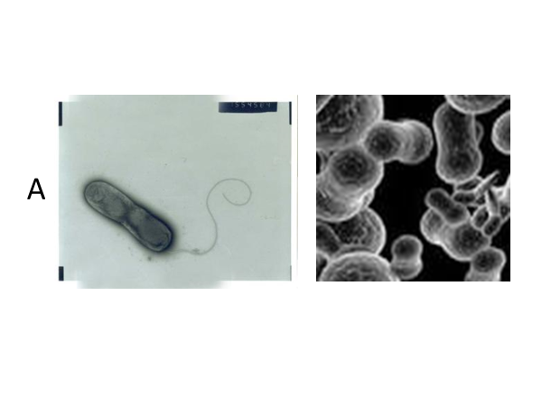
Rhodoferax ferrireducens
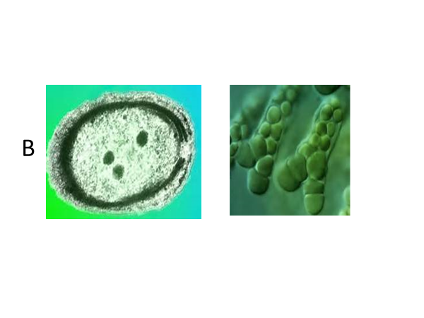
Prochlorococcus marinus
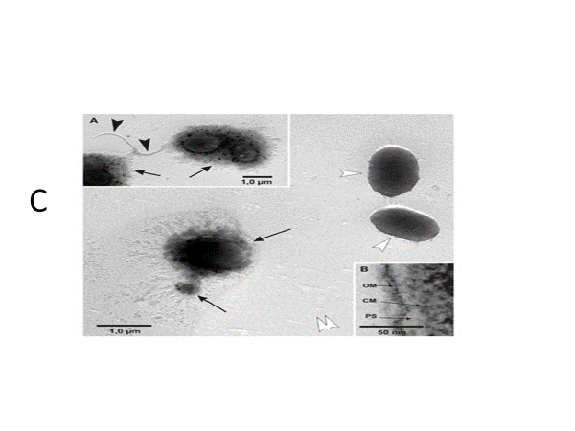
Dinoroseobacter shibae

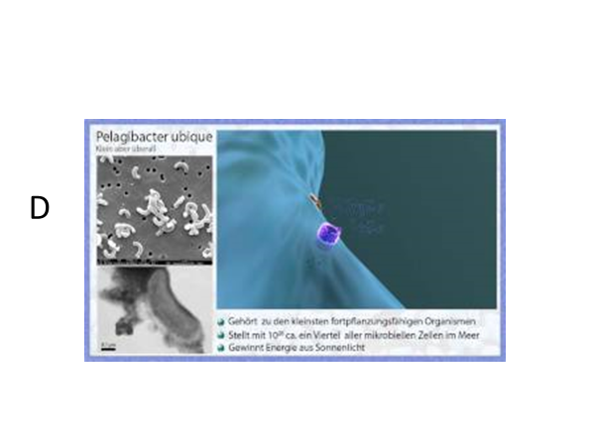
SAR 11 peligbactor
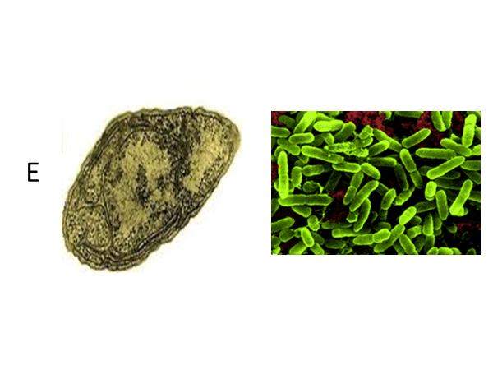
Nitrosomonas

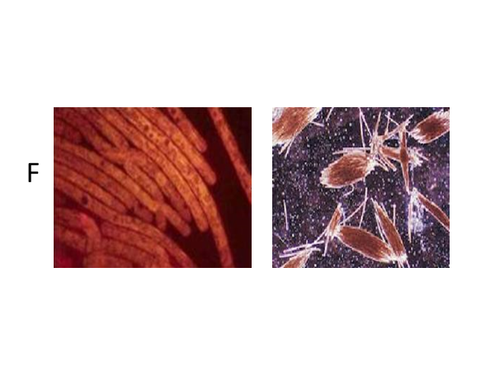
Trichodesmium erythraem
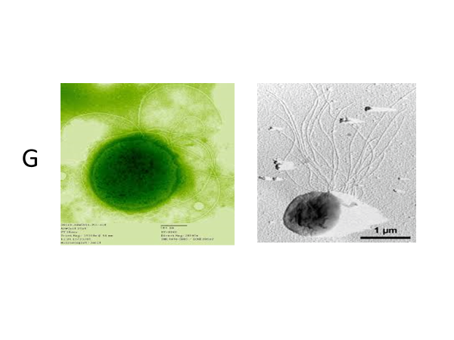
Thermococcus gammatolerans

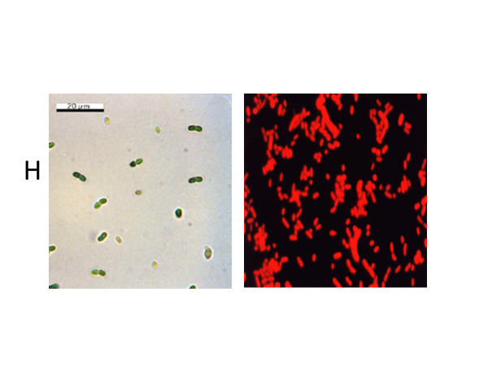
Synechococcus

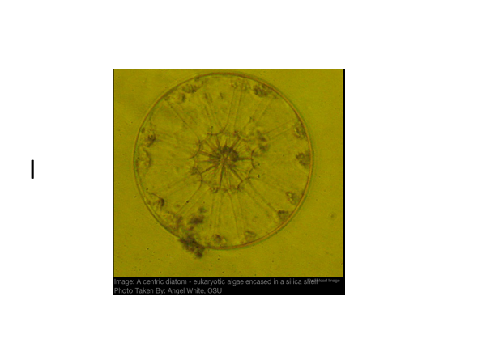
Diatom

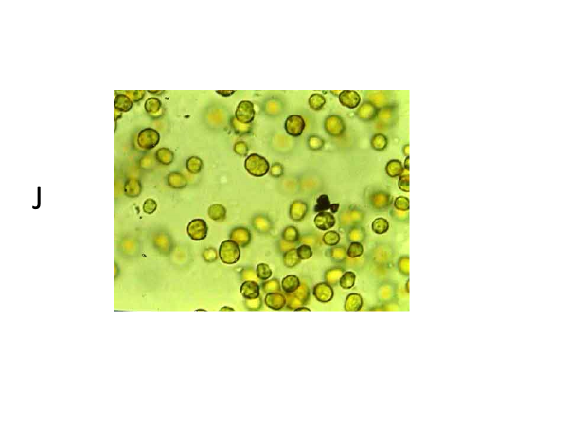
Zooxanthellae/ dinoflagellate
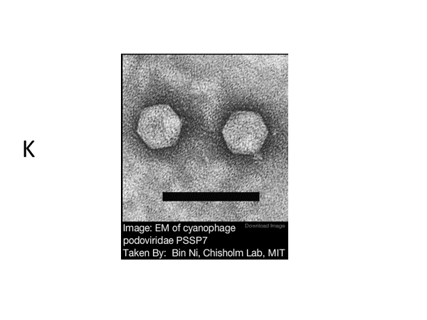
Cyanophage
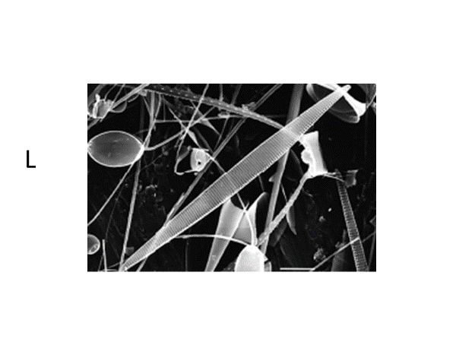
Pseudo-nitzschia australis

Enrichment Activity:

Students, using the internet or other resources, can look up the microbes from the cards, and give a brief description about them. Descriptors might include, type of microorganism, what part of the ocean they live in (deep, shallow, near shore, etc.), their food source, and/or the role they play in the environment.

Lesson adapted from: Monterrey Bay Aquarium Research Institute. Lesson: Microbes are a BLAST. http://www.mbari.org/microbes-are-a-blast/

